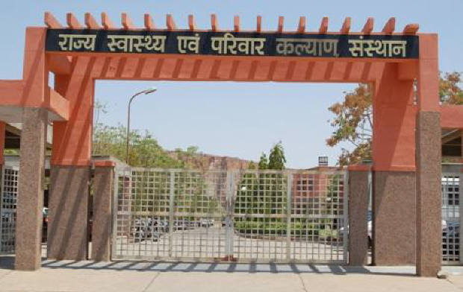

**SIHFW Rajasthan**

***Electronic Newsletter***

***January to March 2025*  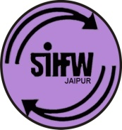**

SIHFW: an ISO 9001:2015 certified Institution

**From the Director’s desk…**

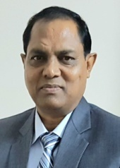

*Dear Friends…*

*This issue of e newsletter is being release at the time of closing of financial year. This issue of newsletter is giving coverage of all activities completed during the last financial year 2024-25. The past one year has been full of accomplishments and learning experiences at SIHFW. We at SIHFW, together geared up for completing all training targets and also celebrated national days such as Republic Day and colorful festival of Holi! We request all readers to kindly pour us with your feedbacks and suggestions to make this institute a better one and also for this e newsletter.*

*We would solicit your feedback and suggestions.*

*Best Wishes!!*

*Dr. S.S. Agrawal*

*Director-SIHFW*

|  |  |
| --- | --- |
| *Some important health and social days for January to April 2025* | |
| World Leprosy Day 2024-Jan 30, 2025 | World Health Day-April 7, 2025 |
| World Cancer Day Feb 4, 2025 | World Parkinson Day-April 11, 2025 |
| National Safety Day- March 4, 2025 | National Safe Motherhood Day-April 11, 2025 |
| International Women’s Day -March 8, 2025 | World Hemophilia Day-April 17, 2025 |
| World Kidney Day-March 12, 2025 | Earth Day-April 22, 2025 |
| World Down Syndrome Day-March 21, 2025 | World Malaria Day-April 25, 2025 |
| World Tuberculosis Day -March 24, 2025 | World Day for Safety and Health at Work-April 28, 2025 |
| World Autism Awareness Day –April 2, 2025 | World Birth Defects Day-March 3, 2025 |
| India- National Birth Defect Awareness Month 2025-March | |

**Republic Day Celebration at SIHFW- 26th January, 2025**

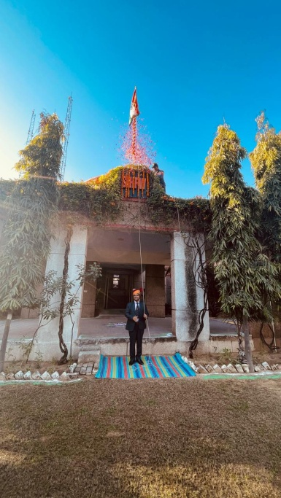

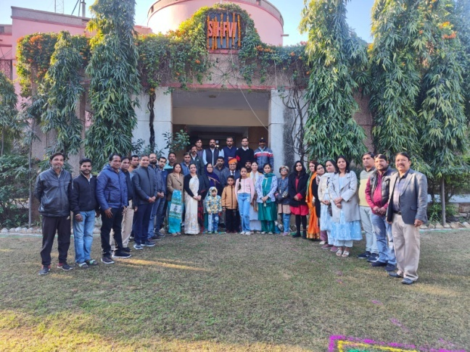

On every Republic Day, as a step towards motivating staff to work better, selected staff is awarded at SIHFW. They are presented ‘Certificate of Excellence’ by Director SIHFW. This year 2025, Ms Nishanka Chauhan, STA, Ms Reena Miglani, Mr. Sunil Joshi, PA to Director, Mr Umashankar, ACT and Mr. Kishore, Gardener were recognised for their good work.

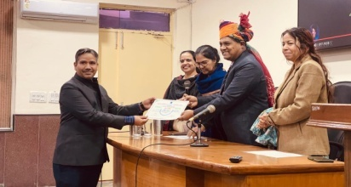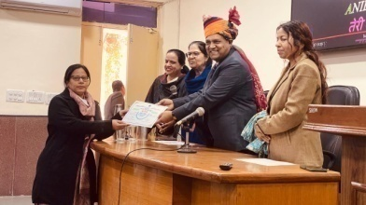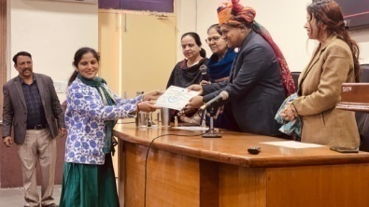

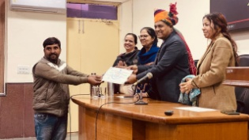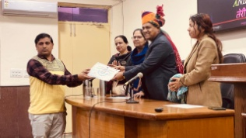

**Festival of Colours-Holi Celebration at SIHFW!!**

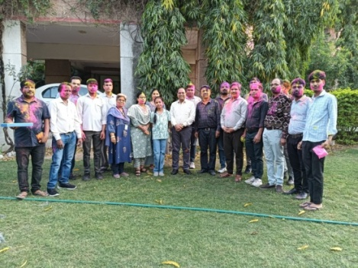



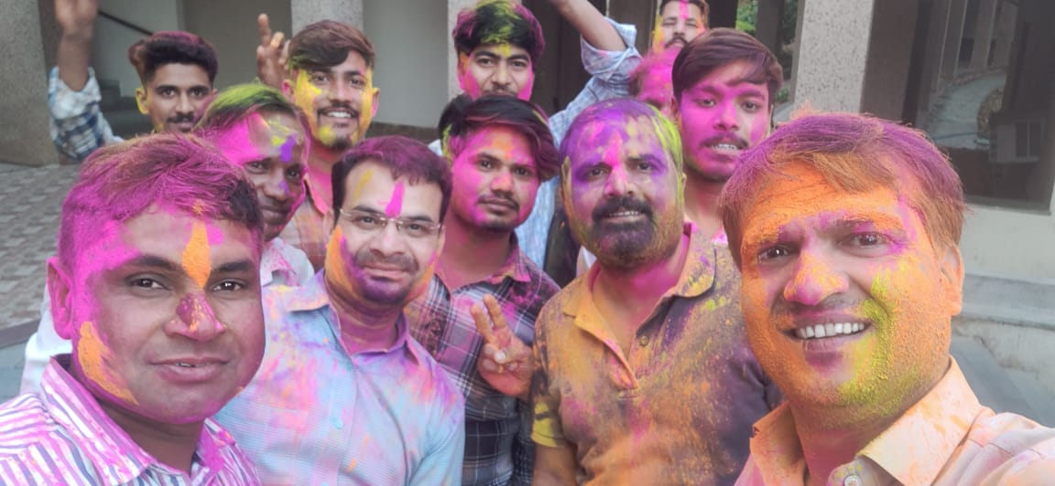

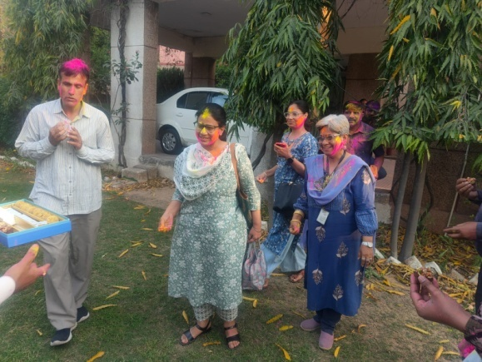

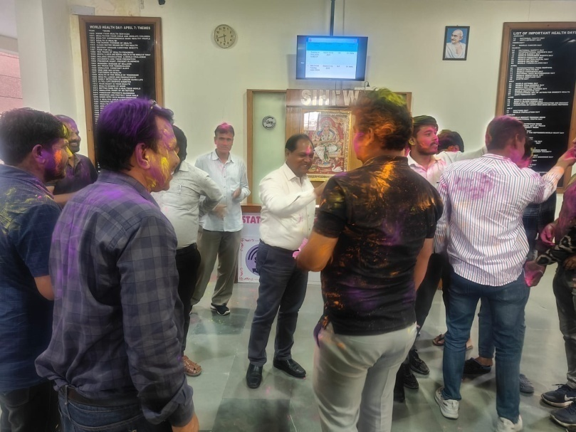

**SIHFW Staff Meetings**

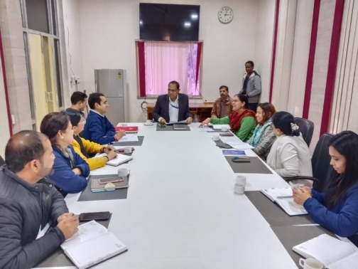Staff Meetings was organised at SIHFW under chairmanship of Director SIHFW. These meetings are organised to review training progress and give quality inputs in planning of all trainings in the State. First meeting of this quarter was organised on January 23, 2025. These meetings also provide opportunity for all coordinators for cross learning from each other.

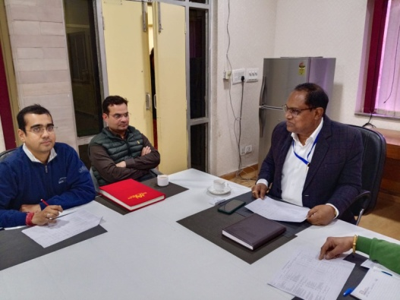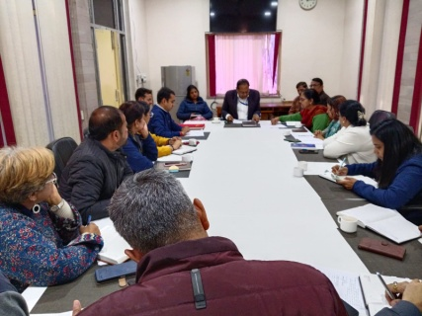

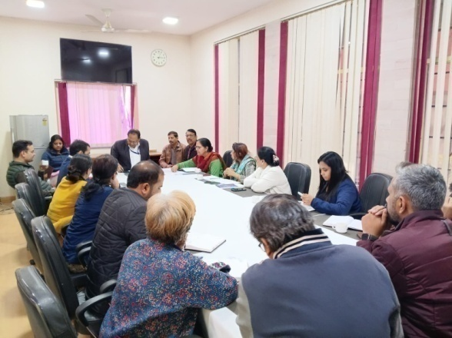

**Regular Sessions on Organ Donation at SIHFW**

Sessions on Organ Donation are being organised at SIHFW in every training batch. Participants are oriented about the organ donation, legal provisions and clinical conditions for organ donation and procedure for registration. Sessions are delivered by experts from Mohan Foundation (NGO specialising in work of organ donation).

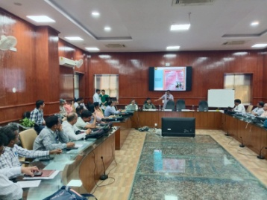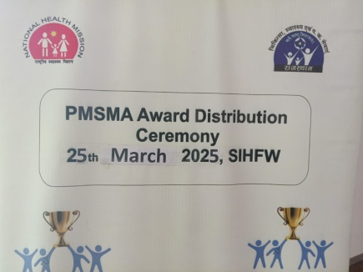

**PMSMA Award Function**

A Ceremony of 1 day was organised at SIHFW. 90 participants attended this function. This ceremony was organised on March 25, 2025 at SIHFW.

**Prasav Watch Launch**

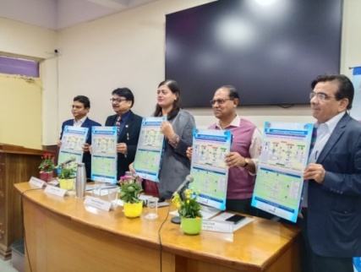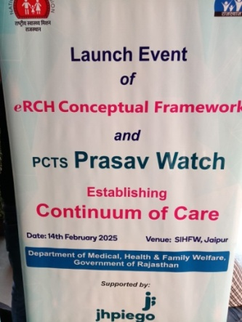PCTS Prasav Watch was launched at SIHFW on February 14, 2025 at SIHFW. It was the launch event of eRCH Conceptual Framework and PCTS Prasav Watch. It was supported by Jhpiego. One day State-level workshop was also organised for orientation on e RCH Framework and PCTS Prasav Watch Application and Dashboard Support.

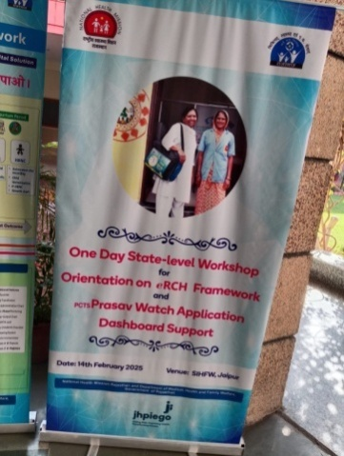

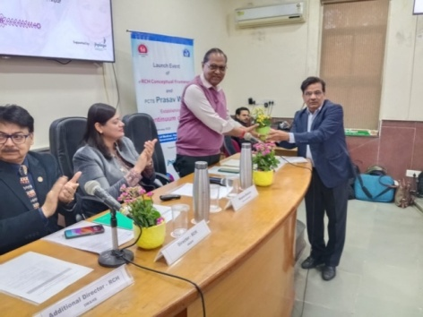

**Trainings at SIHFW**

**Training of Trainers (ToT)**

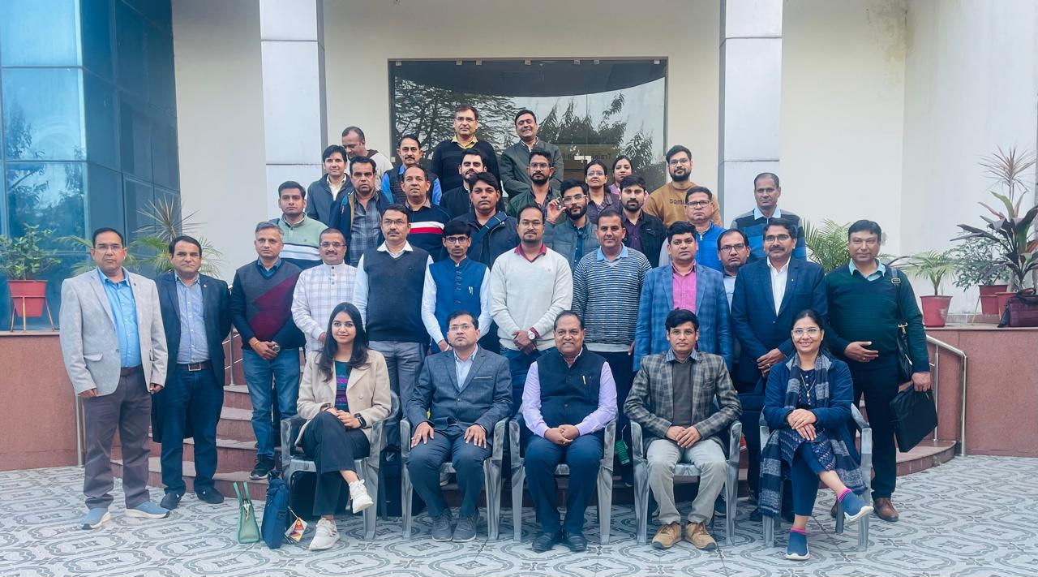**ToT on Eat Right**

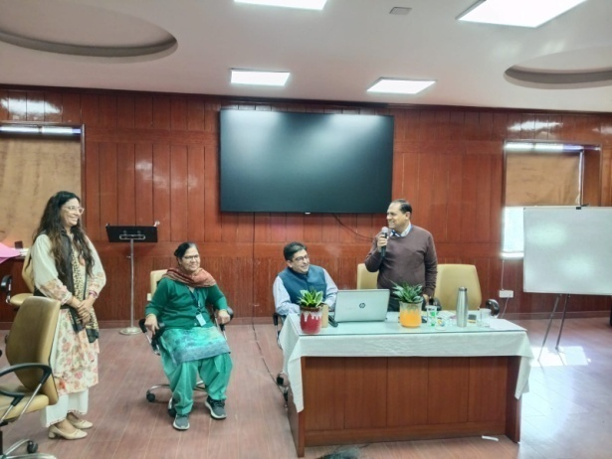These trainings were organised at HWCs and 6 batches as planned were completed in last financial year and 172 participants became trainers in these ToT batches. 1 State ToT batch was also organised at SIHFW on January 24, 2025.

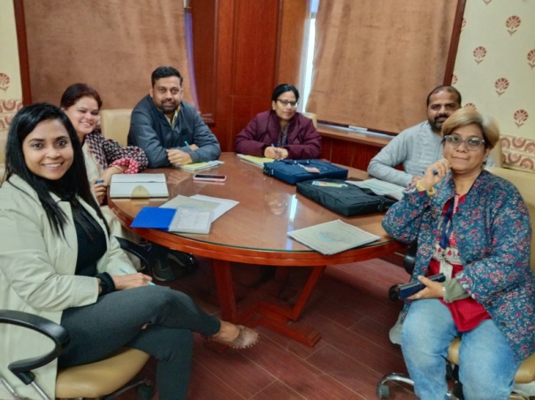

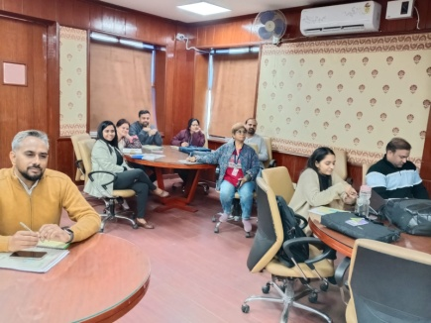

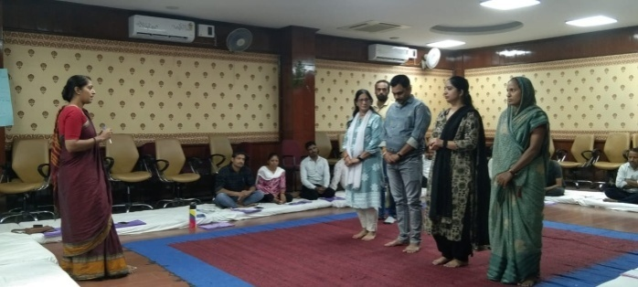**Trainings on PLA**

**ToT on PLA**

This ToT is organised on Participatory Learning in Action (PLA). This batch was initially organised for 5 districts- Baran, Banswara, Dungarpura, Udaipur and Pratapgarh. Now from this financial year 5 more districts have been added. These are Ajmer, Chitorgah, Jhalawar, Pali ad Rajsamand. Participants include BHS and PHS.

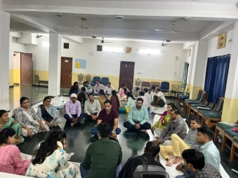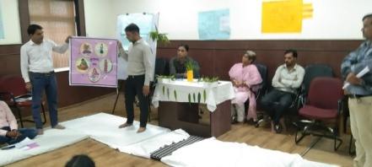This training is organised at SIHFW with technical support of Ekjut. Sitting arrangement for this training is done on floor with dari and mattresses because this training has relevance with village level field work. Participants of this training will work with staff and community for developing village social maps of available resources and develop village plans with community involvement. Participants will organize PLA sessions at field level involving community members and field functionaries.

Role plays are organised on VHSNC meetings and Community Meetings. These dummy meetings are organised on various themes such as PLA, Identification of problems and preparing strategies, Family Planning, Safe Abortion, Nutrition, etc.

In State ToT, 2 batches have been organised at SIHFW and 29 participants were trained as Master Trainers.

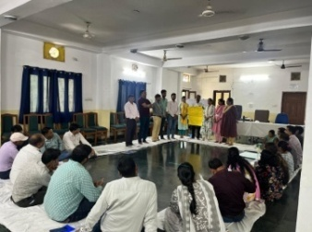These trainings are also organised at Udaipur coordinated by SIHFW. 4 batches were organised at Udaipur.

District ToT on PLA 27 batches were organised at SIHFW and Udaipur for selected districts and 546 participants were trained on PLA.

**ToT on CAC**

This was a one day ToT organized on November 12, 2024. Specialists , Gynaecologists participated in this training. Participants trained in this training became trainers for CAC training. 82 participants were trained in this ToT at District Hospital level.

**Dakshta ToT**

This was a five days ToT organised at SIHFW, one batch was planned and organised. 19 participants were trained in this training.

**ToT FIMNCI**

One batch was planned and organised and 19 participants were trained. This is a 5 days ToT organised at SIHFW for Pediatricians. These specialists further provide training on F-IMNCI training to nursing staff. During this training participants are taken for field visit for hands on learning to JK lone Hospital Jaipur. This batch was organised on August 5 to 9, 2024.

**ToT of District ASHA Trainers**

This training is at present longest duration training organized at SIHFW. This is a 15 days Hybrid training where 8 days online sessions are organized and 7 day offline sessions are organized at SIHFW. 2 training batches were organized at SIHFW during this financial year and 44 participants were trained in this ToT. During offline sessions, participants are trained on skill hands-on practice, with skill demonstration. Participants appear in skill assessments based on OSCI, mock sessions and written paper. Only when participants qualify passing marks, they can become District trainers to give training to ASHA workers. Training methodology also includes Case discussions, written assignments, Role play, lecture methods, etc.

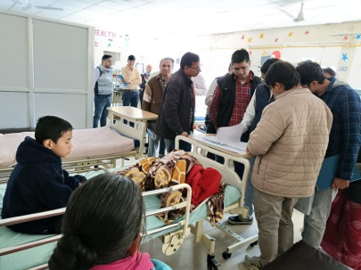**ToT IMNCI**

This ToT is of days and mix group of MD- PSM, Pediatricians, NT/NO/PHN, DPM/DAC etc participate in this training and become IMNCI trainers for ANMs and Nursing staff. During this training participants are taken for field visit for hands on learning to JK lone Hospital Jaipur. This is a 5 days training and 10 batches were organised at SIHFW and 243 participants were trained including DPM, DAC, Pediatricians, MD-PSM, NO, NT, PHN.

IMNCI Training for MOs/SN is also organised at Districts and 56 batches were organised and 773 participants were provided training on IMNCI.

**ToT on New Contraceptives**

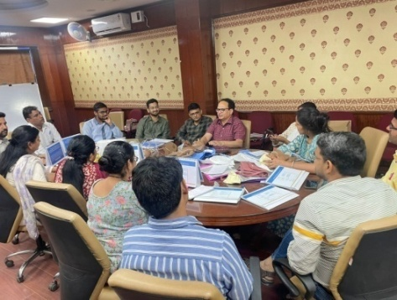ToT on new Contraceptives (Antra and Chaya) was organised at SIHFW in last financial year. One batch was planned and organised. 22 participants were trained in this training. Participants include Medical Officers and Nursing tutors. Participants became trainers for field functionaries. This training batch was organised on August 29-30, 2024.

**ToT NSSK**

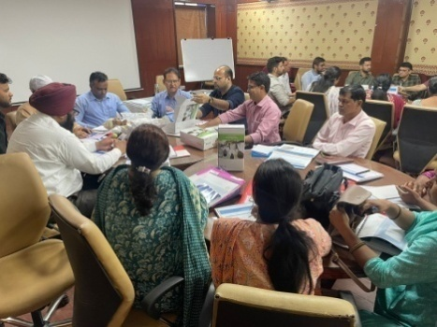Medical Officers and Nursing Tutors are provided this training to become trainers for field staff on NSSK. This is a 2 days ToT and this batch was organised at SIHFW on July 18-19, 2024. 39 participants were trained in this training and one batch as planned was completed in this training.

**ToT on Community Action for Health**

This was a 2 days ToT and 2 batches were organized on November 11-12, 2024 and November 13-14, 2024 and total 36 participants were trained in this training. Participants included DPM, DAC, BPM.

**ToT HBYC**

HBYC ToT was organized at SIHFW, during this financial year and one batch as planned was organized and 28 Sector Health Supervisors (SHS) were trained in this ToT.

**ToT AFHS for MOs**

One batch was planned and completed and 26 trainers were developed in this ToT at SIHFW. This was a 2 days ToT organised on RKSK. Participants under this training were MOs and after this training they will give training to MOs and ANM. This batch was organised at SIHFW on August 28-29, 2024.

**ToT on Bio-Medical Waste Management**

One day ToT on Bio Medical Waste was organised at SIHFW on December 20, 2024 and 45 participants were trained. Participants included MOs, Nursing staff and Waste Handlers.

**State ToT on CAH**

2 batches s planned were organised on Community action For Health at SIHFW under community engagement programme.36 trainers were developed under this ToT.District ToT are also organised on CAH and 9 batches were completed in last financial year and 240 participants were trained in these District ToT.

**Training of Trainers under Gender based Violence**

2 batches and 84 participants were trained in these trainings organised at SIHFW.

**Maternal Death Review Training**

One such training was organised at SIHFW and 80 participants received training in this activity.

**Training of RMNCH/FP Counselors**

23 participants were provided training in this training and one batch as planned was completed in the financial year.

**RKSK Counselor Orientation Workshop for FP**

72 participants were trained in this training and one batch was completed in this training as planned.

**Foundation training of Newly Recruited Medical Officers**

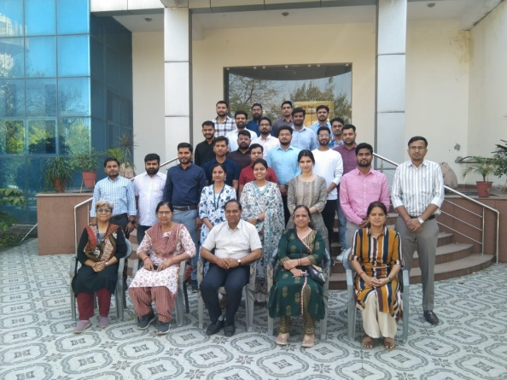This is a 12 day training provided to newly recruited Medical Officers. Objective of this training is to orient the newly recruited MOs to learn about the various health programmes and schemes, latest guidelines, Acts, rules and regulations and government procedures, which they have to perform as a Medical officer. The training focuses on sharpening administrative skills of MOs along with clinical roles and responsibilities. 6 batches of Foundation training were organized during last financial year and 163 Medical Officers were trained in these 6 batches.

Participants were also taken on field visits to observe UPHC Gandhinagar for Quality Assessment and Certification Process. Participants are given hands on exposure in skill lab of SIHFW on various work stations and with dummies.

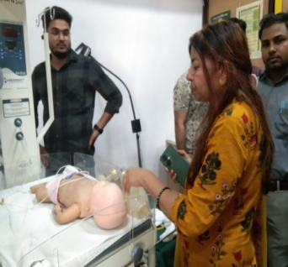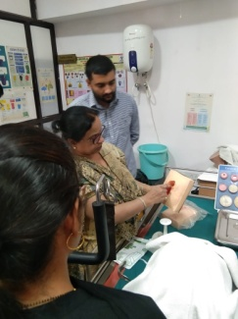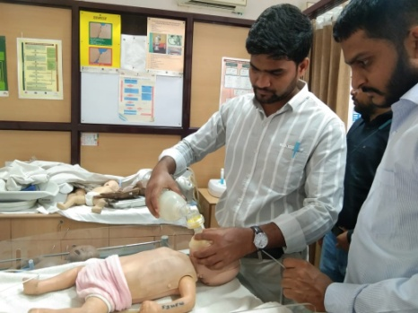

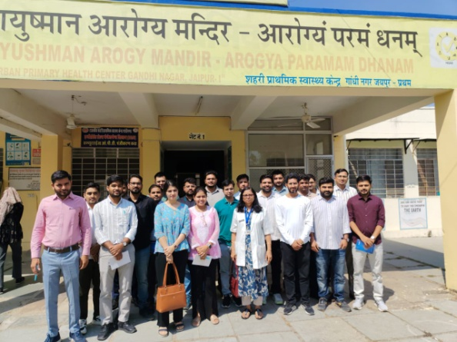

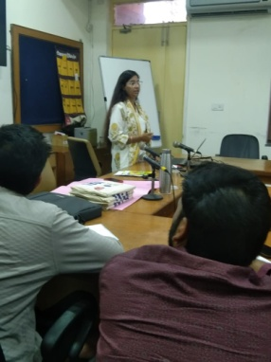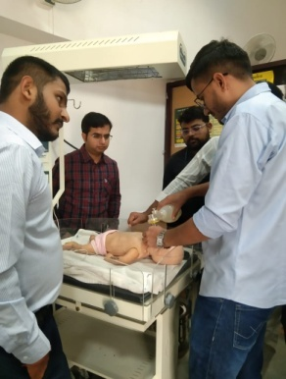

**Training under National Rabies Control Program**

2 batches of training on Rabies control were organised at SIHFW and 107 participants were trained in this training based on rabies control program.

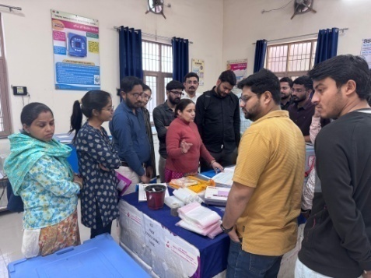**Trainings under Immunization Program**

**Routine Immunization Training for Medical Officers**

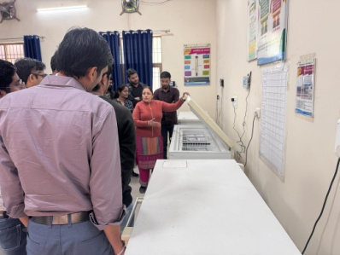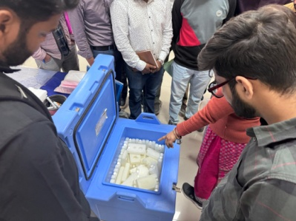Routine Immunization training is of 3 days duration organized for Medical Officers at SIHFW. Training batches always scheduled such that first day of training is on Tuesday so that participants get an exposure visit of Routine Immunization session planned on Thursdays (MCHN day). Immunization schedule, AEFI, Cold chain, Vaccine Management etc are the components of this training. 20 batches have been organized at SIHFW during last financial year and 380 Medical Officers were trained.

**AEFI**

2 batches of AEFI training as planned were organised at SIHFW and 85 participants were trained in this training.

**NCCMIS Training RMs**

2 batches as planned were organised and 44 participants were trained in this training.

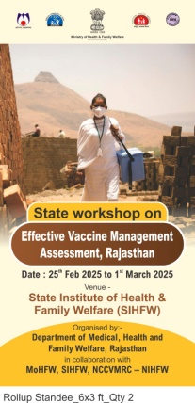**EVM Assessment 5 days training of Assessor**

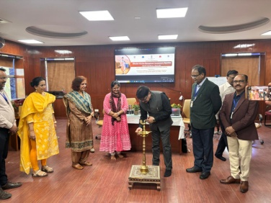One batch was planned and completed and 43 participants were provided training. This training was organised as a part of State workshop on Effective Vaccine Management Assessment. This assessment was done by Dept. of Medical and Health services, Government of Rajasthan in collaboration with MoHFW, SIHFW and NCCVMRC-NIHFW. The workshop was arranged on February 25 to March 1, 2025. After the workshop, assessment was done in field areas of selected districts of Rajasthan. Field visist were done during March 2 to 8, 2025.

**Orientation for BCMOs**

Two days training –Orientation on Cold Chain for Block level Officials is organized at SIHFW. BCMOs and Medical Officers participate in this training. During last financial year 10 batches were organized and 284 participants were trained in this training.

**AFHS Training of Medical Officers**

Training on Adolescent Friendly Health Clinics is provided to Medical Officers under RKSK program. This training is organised at SIHFW and planned 4 batches were organised in last financial year and 105 Medical Officers were provided training.

**Prevention Control and Management of Snakebite**

4 batches and 137 Medical Officers were trained in this training.

**Trainings under NVBDCP**

**Malaria Microscopy**

11 batches of Malaria microscopy training were organized at SIHFW in last financial year. In this 5 days training for Lab assistants and Lab technicians are trained in these trainings. 253 participants were trained in these trainings.

**Training on Dengue and Chikunguniya**

8 batches of this training were organised at SIHFW and 164 participants were trained.

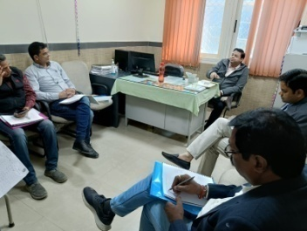

**NPPC Training –visit to SMS**

Training on Palliative care is organised at SIHFW and exposure visits are arranged at Centre for Palliative Medicine and care at SMS Hospital, Jaipur.

**Trainings on Oral Health**

These training were orgaisned for SAHA, ANM, Dental and Paramedical staff on oral health. 5 batchesas planned were completed and 243 participants were trained at SIHFW.

**Deafness training for Medical Officers**

Screening training for deafness was organised at SIHFW for Medical Officers. 3 batches were completed and 91 Medical Officers were trained in this training.

**Trainings under Quality Assurance Program**

Training on National Quality Assurance Service (NQAS) was organized at SIHFW on October 28-30, 2024 and 64 participants were provided training. Participants included BCMO, MO, NO, SNO participated in this training.

**NQAS training on AEFI**

Specialised training on NQAS for AEFI was organized at SIHFW for RCHO and NQAS assessors on October 7 and 8, 2024 in 2 batches. 85 participants were trained in these trainings.

**Bio Medical Waste Management under Kayakalp**

12 batches of this training were organised at SIHFW.

**IQVIA training for Tuberculosis Officers**

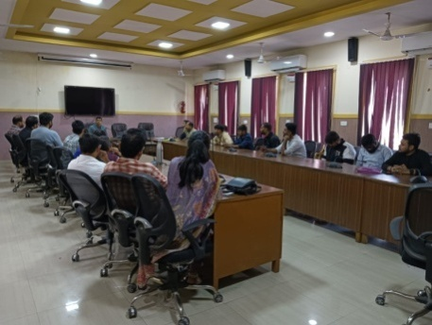This was a one day training and 2 bathes were organized at SIHFW on December 11 and December 12, 2024. 88 participants were trained. District Tuberculosis Officials were participants.

**Training on Mental Health for Medical Officers (NMHP)**

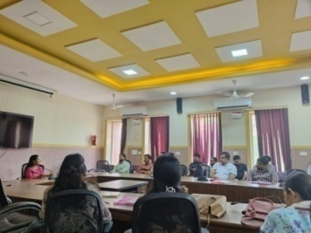This is a five day training of Medical Officers focused onSuicide Prevention and management. 14 batches have been organised by SIHFW and Medical Officers are trained in these training batches. Participants are taken for a visit to Psychiatric centre, SMS, Jaipur and they are provided case studies which are discussed and analysed through discussions. 365 participants were trained in these 14 batches.

**ASHA Refresher ToT training**

ASHA Refresher ToT trainingis organized under ASHA Program. This is a six day training organized for refreshing knowledge of District ASHA trainers and mentoring and facilitation staff including ANM/SHS, etc. This training develops better supervision skills in facilitators to provide hand holding for ASHA workers. During last financial year 4 batches were organised and 78 participants were trained.

**NSSK training**

These training are of two days and are organized for ANM and Staff Nurses. These trainings are organized at District level but for Bharatpur zone batches are organized at SIHFW. NSSK batches for ANM 3 batches were organized and 70 ANM were trained. NSSK for Staff Nurse training, 2 batches were organized and 46 participants were trained.

**Training of Dental MO under NOHP**

This is a one day training of Dental Medical Officers under National Oral Health Program. This training is organized at SIHFW. 2 batches was organized on September 30, 2024 and October 1, 2024. Total 127 participants were trained in these two batches.

**Other trainings at Medical College Level organised by SIHFW**

Training on Blood Storage Units is organised for 3 days at SDMH Hospital. 5 batches planned were completed and 196 participants were trained in this training.

**Hemoglobinopathoes Training MOs**

2 batches were planned and completed at JK Lone hospital.

**AFHS Training of ANM/LHV**

5 batches planned were completed and 93 participants were trained. These batches were organised at HFWTC.

**Field Trainings organized by SIHFW**

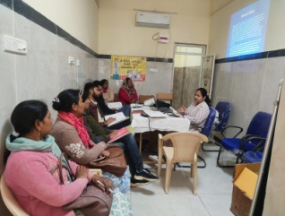**Comprehensive Abortion Care (CAC)**

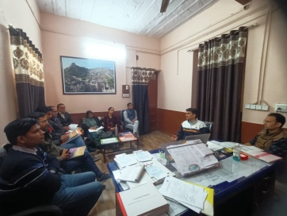Training on Comprehensive Abortion Care (CAC) is organised at District or equivalent hospitals, for 12 days. During last 3 months, 34 batches of CAC training were organised at Jhalawar, Rajsamand, Phalodi, Gangapurcity, (these are the selected training venues). Medical Officers are provided this training. This is a complete hands-on training.

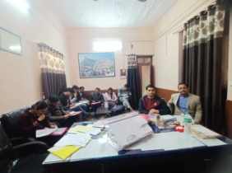

**Medical Method of Abortion (MMA) Training**

This is a clinical training organized at District Hospitals for Medical Officers. 20 batches have been completed in last financial year. MMA training was organized at Medical College level by SIHFW. 92 participants were trained in this training.

**Safe Abortion**

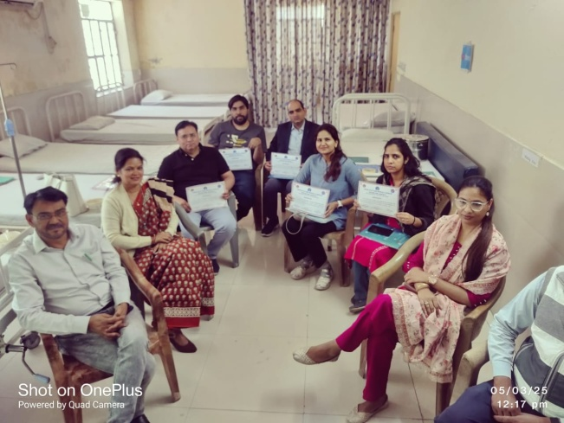

46 batches of Safe Abortion were organised and 173 participants were trained at District level in last financial year in this training organised by SIHFW.

**Laparoscopic Sterilization**

This training is organized for doctors/ specialist at Districts. 3 batches have been completed in last financial year and 11 participants were trained in this training. Dr Ajapa Chomal, STA and Dr Rajni Singh, JTA monitored this training at Sanganeri Hospital.

**NSV for MOs**

5 batches as planned were organised at Districts and 20 participants received NSV training in last financial year.

**RI for HW**

Routine Immunization training for Health workers is of 2 days duration and is organized at Districts for Health workers-ANM, GNM, LHV and Nursing staff. Participants are oriented on Routine Immunization schedule, AEFI, cold chain management, vaccine storage and micro planning of routine immunization, social mobilization and reporting mechanism. 25 batches have been completed in this training at Districts and 664 Health workers were provided training.

**Training on NPPC**

Capacty building incl. Training (Training pf PHC MO,Nurse,Paramedical Worker & other Health Staff)-13 batches were orgainsed and 153 staff were trained on NPPC at district level on NPPC.

**PE Training under RKSK program**

Training for Peer Educators are organised at Block level in selected Districts- Banawara, Bundi, Karauli, Jalore, Udaipur, Sanchor, Salumber – 28 batches were organised and 1120 staff were trained in this training organised at district level under RKSK program.

**Eat Right Trainings for MOs and CHOs**

These trainings are of one day each and at present these are on-going in Districts.

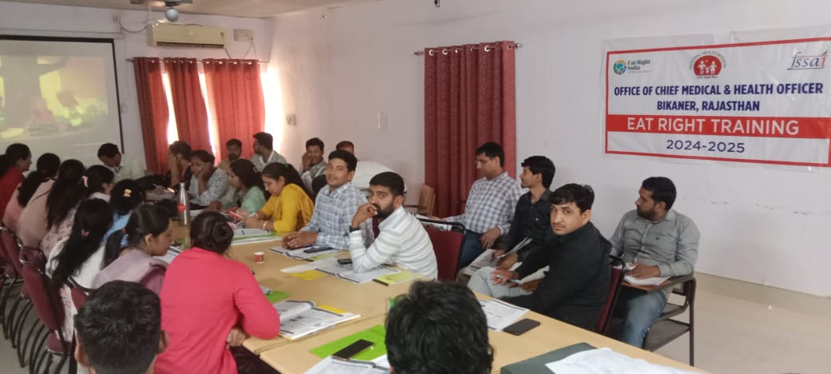

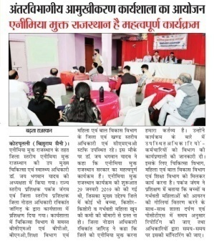**One day orientation block level FLW and PEEOs on Anemia Mukt Bharat** (**AMB)**

10 batches and 248 participants have been trained so far and these trainings are of continuous nature.

**One day orientation block level officials of health ICDS and school on Anemia Mukt Bharat** (**AMB)**

28 batches and 427 participants have been trained so far and these trainings are of continuous nature.

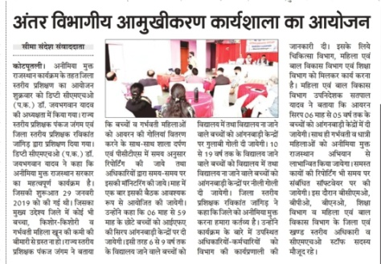

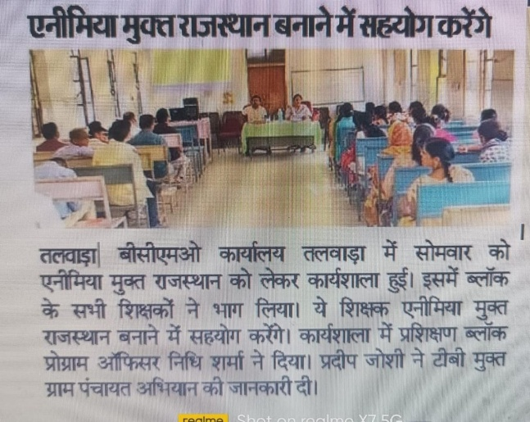

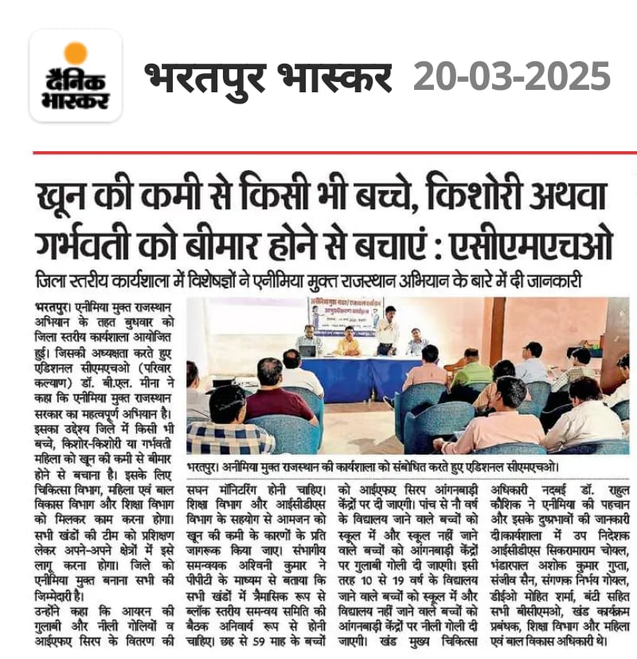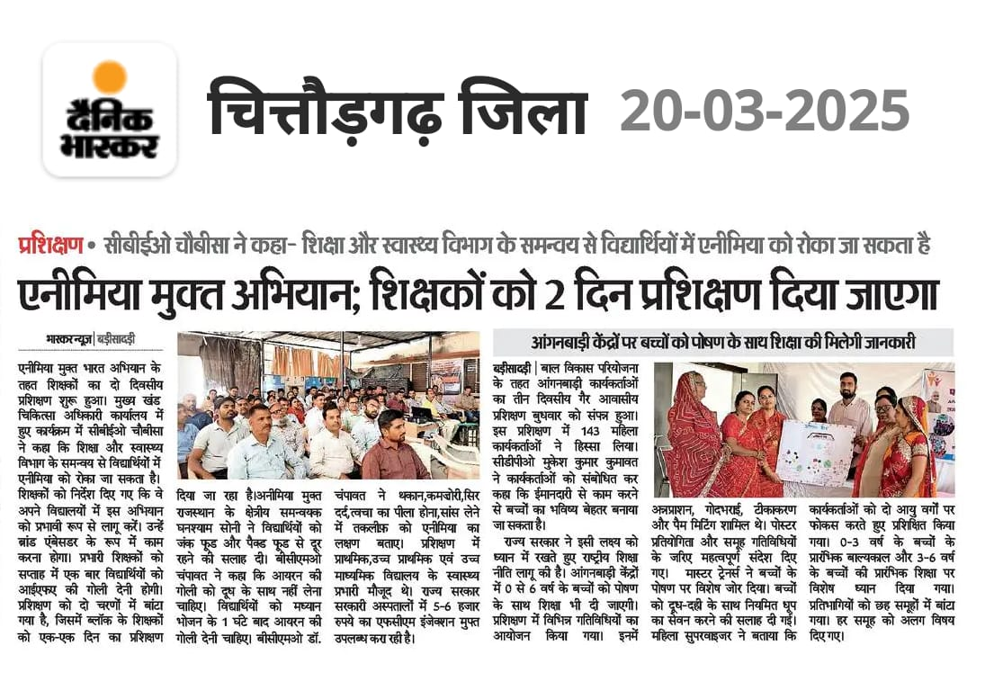

**Health News**

# New WHO guidance calls for urgent transformation of mental health policies

The World Health Organization (WHO) today launched new [guidance](https://www.who.int/publications/i/item/9789240106796)to help all countries reform and strengthen mental health policies and systems. Mental health services worldwide remain underfunded, with major gaps in access and quality. In some countries, [up to 90% of people with severe mental health conditions](https://www.who.int/publications/i/item/9789240049338) receive no care at all, while many existing services rely on outdated institutional models that fail to meet international human rights standards. The guidance provides a clear framework to transform mental health services in line with the latest evidence and international human rights standards, ensuring quality care is accessible to all. "Despite rising demand, quality mental health services remain out of reach for many people," said Dr Tedros Adhanom Ghebreyesus, WHO Director-General. "This new guidance gives all governments the tools to promote and protect mental health and build systems that serve everyone.”

## A blueprint for mental health care transformation

While effective prevention and treatment interventions exist, most people living with mental health conditions do not have access to these. The new WHO guidance sets out concrete actions to help countries close these gaps and ensure mental health is promoted and protected, with a focus on:

* protecting and upholding human rights, ensuring mental health policies and services are aligned with international human rights standards;
* promoting holistic care with an emphasis on lifestyle and physical health, psychological, social, and economic interventions;
* addressing social and economic factors that shape and affect mental health including employment, housing and education;
* implementing prevention strategies and promote population-wide mental health and well-being; and
* ensuring people with lived experience are empowered to participate in policy planning and design to ensure mental health policies and services are responsive to their needs.

The guidance identifies five key policy areas requiring urgent reform: leadership and governance, service organization, workforce development, person-centred interventions, and addressing social and structural determinants of mental health.

## A tailored approach to strengthening mental health systems

The WHO guidance serves as a critical tool for governments, policymakers, and stakeholders working to strengthen mental health systems and improve access to mental health care. By offering a menu of policy directives, strategies and actions to guide reform efforts, the guidance supports policy makers to prioritize and tailor policies to their specific national context, in line with their available resources and operational structures.

"This new WHO guidance provides practical strategies for countries to build inclusive, responsive and resilient mental health systems. Designed to be flexible, it allows all countries – whether low- middle- or high-income - to adapt their approach to mental health care based on national context, needs, and priorities,” said Dr Michelle Funk, Unit Head, Policy, Law and Human Rights in the WHO Department for Mental Health and Substance Abuse. The guidance was developed in consultation with global experts, policymakers and individuals with lived experience. The policy guidance also builds on the resources, guidance and tools developed under the [WHO QualityRights initiative](https://www.who.int/activities/transforming-services-and-promoting-human-rights-in-mental-health-and-related-areas), aiming to promote a person-centred, recovery-oriented and rights-based approach to mental health. WHO will support countries in implementing the guidance through technical assistance and capacity-building initiatives. Source: WHO Health news, 25 March 2025.

## Steps taken under TB-Mukt Bharat Abhiyan

National TB Elimination Programme (NTEP) under the aegis of National Health Mission (NHM) is implemented across the country with the objective of early detection of TB cases, appropriate management and prevent new TB cases. Specific measures taken by the Government to ensure successful treatment completion for all TB patients including multidrug-resistant TB cases are as under:

* Track all TB patients through Ni-kshay portal for the entire duration of treatment.
* Monitoring of treatment adherence through Ayushman Arogya Mandir and peripheral health workers like ASHAs.
* Link TB patients with community-based treatment supporters like ASHAs community volunteers and provision for incentives to treatment supporters.
* Universal Drug Susceptibility Testing (UDST) is implemented to ensure every diagnosed TB patient is tested for drug resistance at the time of diagnosis.
* 826 Drug Resistant TB treatment centres have been established across all districts for decentralized care
* In 2021, shorter, safer, all oral drug-resistant TB treatment regimen has been introduced.
* In 2024, a newer, shorter and more efficacious treatment regimen consisting of four-drug combination – Bedaquiline, Pretomanid, Linezolid and Moxifloxacin has been introduced for management of drug-resistant TB

TB awareness campaign are organised in all State/UTs with involvement of various local non-government organisations. Further, the Government has launched a 100 days intensified TB Mukt Bharat Abhiyan in identified 347 priority districts across 33 State/UTs, to accelerate the endeavour to achieve Sustainable Development Goals related to TB, wherein Jan Bhaghidari activities are implemented with involvement of elected representatives, line ministries, schools, panchayati raj institutions, self-help groups, anganwadis, local non-government organisations  and civil society organizations to increase awareness on TB to combat stigma and to encourage early health seeking behaviour among the citizen.

To enhance the availability of hand-held X-rays in high burden areas, the government has approved procurement for central supplies. In addition, adequate provisions for procurement have been made through National Health Mission for State/UTs as per need. *Source: Press Information Bureau, March 18, 2025*

## Update on “75/25” Initiative

On World Hypertension Day, celebrated on May 17, 2023, the Government unveiled the "75/25" initiative which aims to provide standardized care to 75 million individuals living with hypertension and diabetes by December 2025. As of March 5, 2025, a total of 42.01 million individuals have received treatment for hypertension, while 25.27 million have been treated for diabetes, achieving 89.7% of the target. To address the rising prevalence of major Non-Communicable Diseases (NCDs) such as hypertension, diabetes, oral cancer, breast cancer, and cervical cancer, the National Programme for Prevention and Control of Non-Communicable Diseases (NP-NCD) was initiated by the Department of Health and Family Welfare, Government of India, in 2010. The program employs a multifaceted strategy that includes:

**Population-Based Screening**: Early detection and screening of individuals aged 30 years and above.

**Opportunistic Screening**: Implementing screening at all levels of healthcare delivery.

**Support for Diagnosis and Treatment**: Providing assistance for accurate diagnosis and cost-effective treatment options.

**Teleconsultation Services**: Utilizing information technology to offer teleconsultation services to citizens.

**National NCD Portal**: Monitoring NCDs through the use of a dedicated portal.

**Awareness and Lifestyle Promotion**: Coordinating inter-ministerial efforts to promote NCD awareness and encourage healthy lifestyle choices.

In response to the increasing burden of NCDs, Ministry of Health & Family Welfare has launched an NCD Screening Campaign from February 20, 2025, to March 31, 2025, with the goal of achieving 100% screening of individuals aged 30 years and above. This nationwide campaign is being conducted across Ayushman Arogya Mandir facilities and other healthcare institutions under the NP-NCD framework.

Monitoring of this initiative involves systematic data collection, performance management, and data quality assurance. Monthly reports from States and Union Territories are compiled and analyzed at the national level, with periodic feedback provided to the States. Additionally, program reports generated from the National NCD Portal dashboard are analyzed at the Centre, State, and District levels as part of a structured monitoring framework, ensuring effective oversight and continuous improvement of the program. *Source: Press Information Bureau, March 11, 2025*

## National Guidelines on Medical Oxygen Management released

The Ministry of Health and Family Welfare has released the National Guidelines on Medical Oxygen Management at a workshop held at the All India Institute of Medical Sciences (AIIMS), Delhi, here today. The workshop also marked the launch of the National Capacity Building Programme on Oxygen Management, which will be led by Department of Hospital Administration at AIIMS, Delhi.

Speaking at the event, Smt. Punya Salila Srivastava, Union Health Secretary emphasized the critical role of properly maintaining and utilizing medical oxygen infrastructure so that demands for any surge capacities may be met promptly at time of any exigencies and stressed on the need for inculcating learnings from India’s management of COVID-19 pandemic. Prof. M Srinivas, Director, AIIMS highlighted the institute’s role in spearheading the capacity-building program and stressed the importance of training and awareness at all levels of healthcare.

The release of National Guidelines on Medical Oxygen Management marks a significant step toward strengthening the country’s medical oxygen infrastructure and ensuring uniform best practices in oxygen management across healthcare facilities. The comprehensive guidelines provide a framework for the efficient procurement, storage, and administration of medical oxygen, with a focus on patient safety, capacity building, and emergency preparedness. The National Capacity Building Programme on Oxygen Management is an initiative led by the Disaster Management Cell of Ministry of Health and Family Welfare in collaboration with AIIMS, New Delhi. It aims to train around 200 master trainers across the country which in turn shall undertake capacity building of hospital administrators and medical officers across the country in proper handling and utilization of medical oxygen, reducing wastage and improving clinical outcomes. *Source: Press Information Bureau, March 27, 2025*

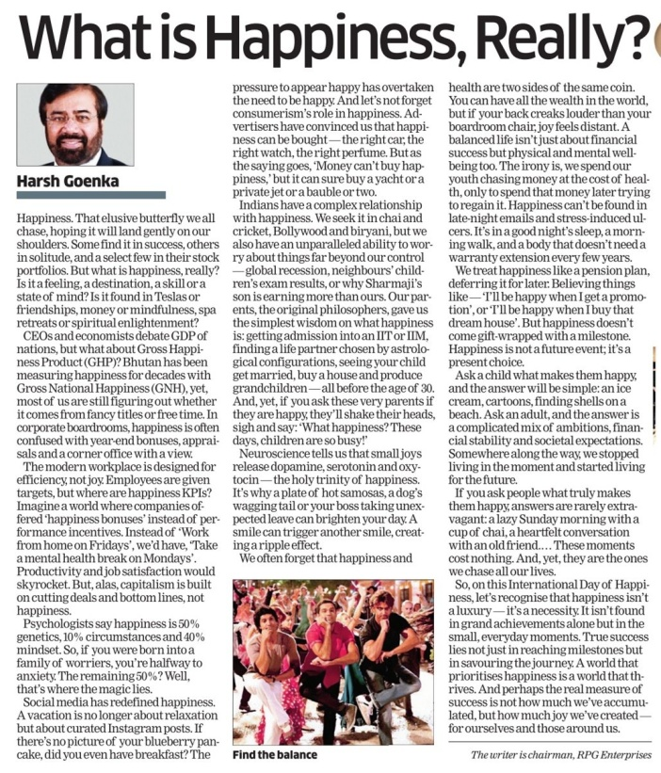

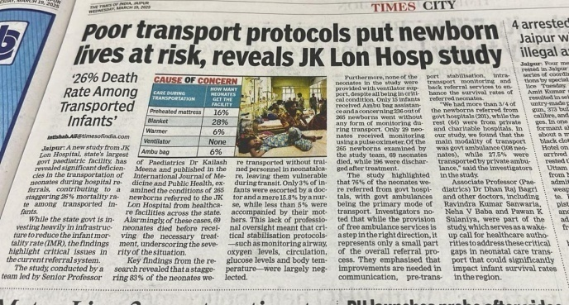

*We solicit your feedback:*

*Editing and Compilation by: Archana Saxena, JTA; IT support: Mohit Dhonkeriya;*

*Mentored by: Dr Bharti Sharma, Faculty-Gynaecology, SIHFW*

State Institute of Health & Family Welfare

Jhalana Institutional Area, South of Doordarshan Kendra Jaipur (Raj)

Phone-2706534

E-mail:-sihfwraj@ymail.com; Website: www.sihfwrajasthan.com